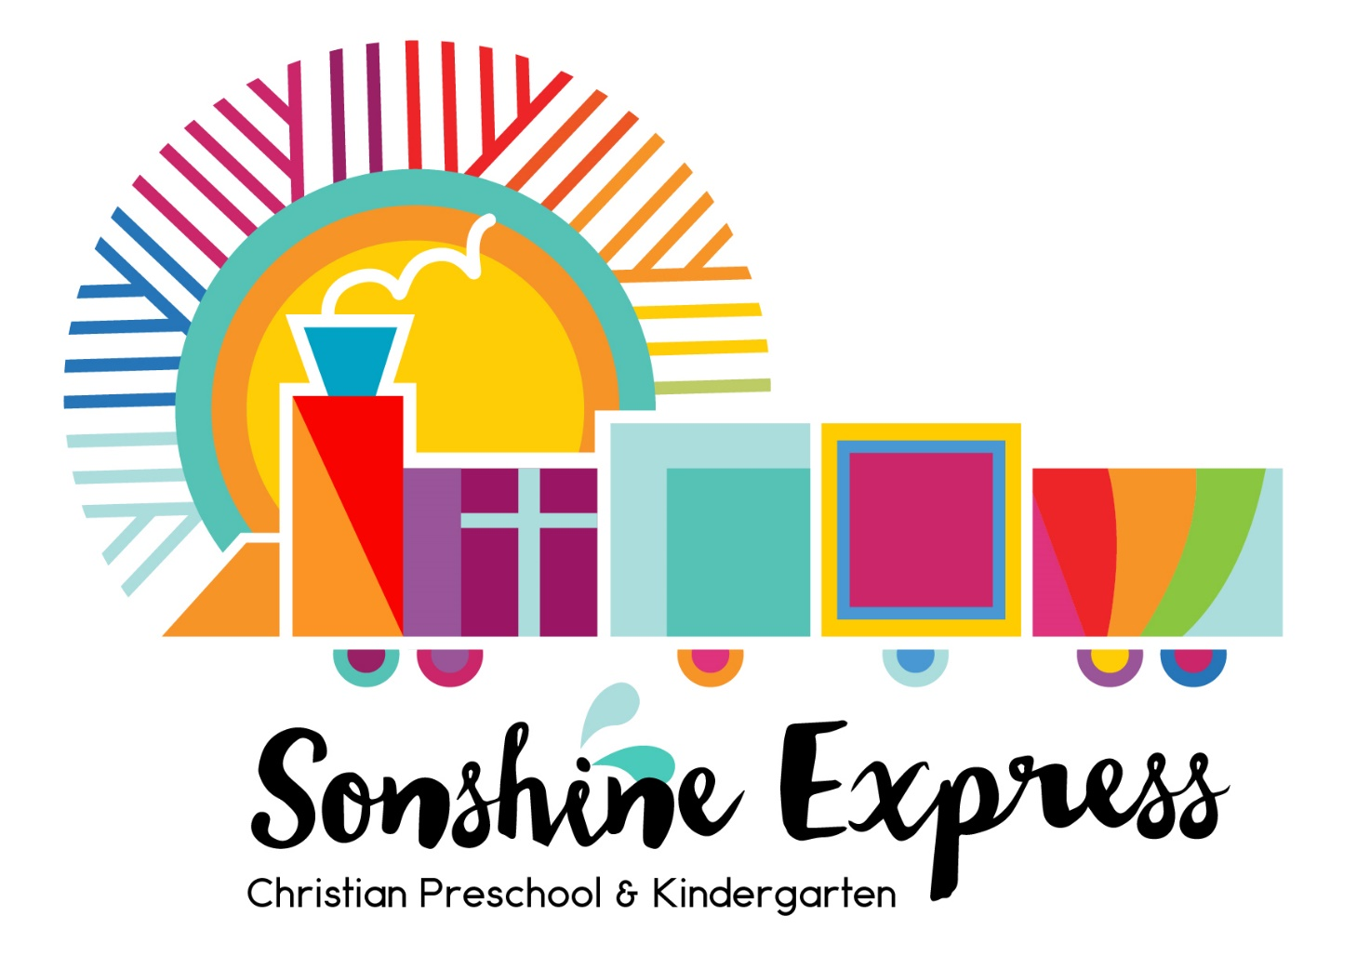

Parent Handbook
2022-2023

Dear Sonshine Express Families,

“Let the little children come to me, and do not hinder them, for the kingdom of God belongs to such as these. I tell you the truth, anyone who will not receive the kingdom of God like a little child will never enter it. And He took the children in His arms, put His hands on them and blessed them.” Mark 10:14

We feel honored and blessed that you have chosen Sonshine Express Preschool and Kindergarten for your child’s early education. With the Lord’s guidance and blessing, we expect to have a fruitful and rewarding year with your children. We look forward to partnering with you!

Please keep this handbook to use as a reference throughout the school year. If you have any questions or need further information regarding our procedures or policies, please let us know.

Blessings,
Jenn Domingo, Director
40 McNary Parkway
Lake Oswego, OR 97035
(503) 635-3761
JennD@mountain-park-church.org

Staff
Teachers at Sonshine Express are Christians who are committed to living daily for Christ. They are involved in and committed to a local Bible believing church, attending regularly, and involved in its ministries. Teachers have a working knowledge of child development and early childhood education, principles, and techniques.

Kathi Bohrer 2 year olds Teacher, Bookkeeper and Assistant Director
Julie Coffman 3 year olds, Pre-K and Lunch & Play Teacher
Jenn Domingo Director, Music, PE and Create & Play Teacher
Paige Glass 3 year olds, Pre-K and Lunch & Play Teacher
Janie Henderson 3 year olds, Pre-K and Lunch & Play Teacher
Chris Marks 2 year olds, Create & Play and Lunch & Play Teacher
Nancy Melrose 3 year olds, Pre-K and Lunch & Play Teacher
Katie Oranen Kindergarten Teacher

History of Sonshine Express Preschool
Sonshine Express was founded in the fall of 1981 as a ministry of Mountain Park Church. Its purpose was to provide a loving and caring environment for children to learn about God through social and scholastic activities. What started as a school of 13 has grown into a 2 year olds through kindergarten program of over 100 children each school year. In the past 41 years, the school has served well over 1000 children and their families. Sonshine Express strives to provide a Christian education and nurturing environment for a child’s early development.

Purpose Statement
To introduce our students to God’s love.
To create a nurturing environment that will enable the students to grow spiritually, socially, and academically.
To partner with families in the training and educating of their children.

Statement of Faith
We believe in one God, Creator and Lord, existing in three persons: Father, Son and Holy Spirit.
Genesis 1:1; Isaiah 40:28; Matthew 28:19
We believe that our Lord Jesus Christ was fully God and fully man, that He died on a cross to restore a right relationship with God by saving us from sin and its penalty of death, and that He rose physically from the grave, giving eternal life to all who reject sin and trust in Him.
John 1:1-14; John 3:16-18; Acts 2:22-39; Acts 4:12; Romans 6:23; 1 Corinthians 15:1-7
We believe eternal salvation means a personal trust in Jesus Christ as Savior and Lord and of the presence of the Holy Spirit in the believer, as Counselor and Guide, providing the power to live in a right relationship with God and humankind.
John 1:10-12; Romans 8:9-11; Romans 10:9-10; Acts 1:8; 1 Corinthians 12:13
We believe the Bible, both Old and New Testaments, is the inspired Word of God, without error and is the complete revelation of His will for salvation, and relationship with all people.
John 17:17; 2 Timothy 3:16; 2 Peter 1:16-21

Philosophy
We believe critical physical, social, emotional, and spiritual development takes place in the first 5 years.
We believe that a child learns through creative discovery and experiences.
We believe a child also learns through instruction by loving and caring teachers.
We believe a child’s education is a balance of play and structured lessons.
We believe in the power of prayer as we pray for students and their families. I Thessalonians 5:17
We believe God’s Word is our model for a Christ-centered life. 2 Timothy 3:16

Enrollment Policy
Sonshine Express’ enrollment is based on availability of openings in the program. Sonshine Express does not discriminate on the basis of race, color, religion, gender, or national or ethnic origin.

Enrollment will follow the State of Oregon’s guidelines for school attendance. A child must turn the appropriate age for the individual classes by September 1st. A child’s enrollment may be terminated on the basis of our school’s guidelines and rules.

We strive to work with parents and children to provide a safe and healthy environment for our students to learn. If it is deemed necessary to terminate a student’s enrollment, reasonable notification will be made to the parents.

If a child has special needs, we will work in a partnership with parents and agencies to provide an atmosphere conducive to learning.

Registration
Registration will start January 1st for current students and siblings. All materials will be due by January 13th to secure your spot for the upcoming school year. Your tuition account must be current in order to register for the following school year. Open registration starts January 16th for new students.

Registration includes:
· Registration Form
· Non-refundable deposit of $100.00
· Non-refundable 1st month’s tuition

Tuition *

Class Tuition: Monthly (September - May) Less 10% Sibling Discount 2 -year olds $100.00 $90.00
3 -year olds $200.00 $180.00
Pre-K $300.00 $270.00
Kindergarten $450.00 (June $225.00) $405.00

Lunch & Play: Offered Monday - Friday
$20.00 per session

Create & Play: Offered Wednesdays for our 3’s $25.00 per session
(2’s beginning in January)

Tuition is paid on a monthly basis. We do not send monthly invoices out. Payment can be made via cash, check or our PayPal link on our website. Please note there is a 2.99% PayPal fee plus .49 cents Transaction Fee if you choose to pay through PayPal. If paying via a PayPal invoice there’s a 3.49% PayPal fee plus .49 cents Transaction Fee. Tuition is due the first week of the month, unless other arrangements have been made. We do have a limited scholarship program based on financial need, please inquire for additional details. If parents are paying in cash, they will need to receive a receipt for the amount. The younger sibling(s) is/are allowed a discount of 10% per child after the first child in the preschool has paid full tuition.

Material Fees
2 year olds $50.00
3 year olds $100.00
Pre-K $150.00
Kindergarten $225.00
This fee is due the by the end of September. This amount will be determined by enrollment and cost of materials.

*Tuition and material fees may be altered according to enrollment or other factors at any time.

Withdrawing from School
If a child needs to withdraw from the school, a 30 day notice is required. Tuition will be adjusted to reflect the 30 days. A letter stating the withdrawal is required.

Important Dates for 2022-2023
1st week of preschool/kindergarten September 5th
Last week of preschool May 29th
Last Day of Kindergarten June 15th
Summer School (optional) June 1st-14th

School Holidays
Sonshine Express Preschool & Kindergarten will honor the following Federal holidays:
- Labor Day
- Veteran’s Day
- Thanksgiving (closed the entire week)
- Christmas (and extended vacation)
- New Year’s Day
- Martin Luther King Day
- Presidents Day
- Memorial Day
Please see the school calendar for exact dates of school closures.

Inclement Weather Closures
Sonshine Express Preschool & Kindergarten will follow the Lake Oswego School District in its inclement weather closures. If Lake Oswego is closed then we are closed. If Lake Oswego is delayed, then the school will be closed. The local media will announce closures and families will receive an email from Sonshine as soon as possible. If Lake Oswego does not declare a snow day due to Distance Learning, Sonshine staff will make the decision and notify families via email regarding closure.

School Hours
2’s: Monday OR Thursdays, 9:00 a.m. – 11:30 a.m.
3’s: Tuesdays AND Thursdays, 9:00 a.m. – 11:30 a.m.
Pre-K: Mondays, Wednesdays AND Fridays, 9:00 a.m. – 11:30 a.m.
Kindergarten: Mondays through Fridays, 9:00 a.m. – 1:30 p.m.
Lunch & Play: Daily 11:30 a.m. – 1:30 p.m.
Create & Play: Wednesdays 9:00 a.m. – 11:30 a.m.

The parking lot is a busy place and we ask that you be extra careful as you walk your family to and from your car. Please do not leave children unattended in the car during drop off. Also, please follow the marked signs and rules of the Mountain Park Church parking lot.

Please drop-off and pick-up at your child’s classroom door. Please complete the sign-in sheet prior to leaving.

Written or verbal permission is required for anyone else to pick up your child other than the parents. You may leave permanent permission for carpool drivers for the year or specific individuals. IF SOMEONE ELSE IS PICKING UP YOUR CHILD, WE NEED TO KNOW! Please let us know the morning of if possible.

Lunch & Play
Lunch & Play is an extended optional program for preschoolers currently enrolled at Sonshine Express. Lunch & Play is from 11:30 a.m. to 1:30 p.m. and is available Monday-Friday. Preschoolers may only attend Lunch & Play on those days that they are at school. The preschoolers spend the first 45-60 minutes playing on the playground or in the gym. This time is then followed by restrooms, washing of hands and then lunch. The preschoolers will need to bring their own lunch and drink. The lunch does not need to be fancy. A sandwich, fruit and drink are sufficient. Please include a fork or spoon, or ice pack if necessary. Please do not send any nut butter of any kind due to allergies within the classrooms. After lunch, weather permitting, the children might go outside to play on the playground or play in their classroom. Please send your child with a coat and shoes that are safe for the gym and the outside playground.

Attendance is by sign up only. You will receive an email with a link to sign up for the upcoming month. You will need a Gmail account and the Google Sheets App to access our monthly sign-ups. The cost is $20.00 per class. We encourage our families to sign up in advance to allow our staff time to be prepared for the number of children that will be attending.

Credits will be given due to illness and/or cancellation.

You must pay when you sign up. The payment box is on the table outside of the preschool office if you are paying by cash or check. Please ask for a receipt if you are paying with cash. If you are paying through PayPal, please indicate that on the sign-ups.

It is important for you to pick up your child on time. If tardiness becomes an issue, we will assess a $1.00 a minute fine for tardiness.

Field Trips
We will offer various “field trips” on our campus and during school hours this year including our Sonshine Pumpkin Patch. Our kindergarteners will visit the zoo in June with their classmates and families.

Rule Guidance and Discipline Policy
Positive discipline techniques are used to help our students learn self-control and positive social skills. Conflict situations are handled with empathy and redirection. Strong communication with parents is a top priority.

A focus on prevention and positive guidance techniques will include:
Modeling appropriate behavior for the children
Listening to the children
Giving acceptable choices whenever possible
Encouraging the children
Noticing when the children are making safe and/or appropriate choices
Setting age appropriate boundaries for the children
Modifying the classroom environment to attempt to prevent problems before they occur

Snacks

Parents sign up to bring snack for the class. This is not required but we encourage everyone to participate as the snack child plays host/hostess to the rest of the class. Snack sign-ups will be sent out electronically at the beginning of the year. We are nut-free school. Please no nut or seed butters of any kind. It’s very difficult for our staff to distinguish. Please read ingredients carefully.

Responsibility for snack includes:
Jug of Water
Nutritious snack
5 oz Dixie Cups
Napkins

The County Health Department has required us to provide only store-bought items for snack. Any homemade snacks will not be given to the children. If you want to bring fruit or something that needs to be assembled, we are able to prepare it here at school. The classroom teacher will advise the parents of a potential food allergy that should be avoided for the snack.

Snack Ideas:
Graham crackers
Goldfish crackers
Fruit (Pre-cut and packaged preferred)
Veggies
Yogurt
Raisins
String Cheese
Birthday Parties
You may bring in a special store-bought birthday snack for your child’s class. Cookies or mini cupcakes are their favorites.

Health
The health of the children at preschool is of great importance to the staff. Please do not bring your child if he/she is sick, has a fever of 100.4 or higher and/or is displaying any symptoms of illness. Students will need to be fever and symptom free for at least 48 hours prior to attending school.

Your child should not be at school for the following communicable diseases:

Diarrhea Chicken Pox Fifth Disease Hand, foot, mouth disease Head lice
Hepatitis A & B Influenza Mumps Mononucleosis Pin Worm
Ringworm Pink eye Roseola Rubella Staph Skin Infections Scabies
Strep Infection Tuberculosis COVID-19

Please notify the office if your child comes in contact or contracts one of these conditions. Outbreaks of any contagious illnesses will be announced to the parents. Also, we would appreciate it if you would call the school when your child is sick or not coming to school that day since we like to pray for them.

Allergies must be listed on the emergency cards. If your child has life-threatening allergies, you must discuss this with your classroom teacher. We are a peanut and nut free school. Please remember this when sending a lunch for Lunch & Play.

Medications
No prescription medication or over-the-counter medication, including aspirin, cough syrup, sunscreen, or nose drops, may be given to a child except under the following conditions:

· A signed, dated written authorization by the parent is on file
· Prescription medication is in the original container and labeled with the child’s name, drug name, dosage, date and doctor’s name.
· Non-prescription medication is in original container, labeled with the child’s name, dosage, and administering instructions.
· All forms will be kept on file for one academic year.

Please be sure that your emergency card is kept up to date with current phone numbers and emergency back-up people should we need to call you before the end of the day. Please keep your cellphone on and check for messages.

Potty Training
Potty training is required for the Pre-K and Kindergarten classes. We will work with you for the 2’s and 3’s. Please use the bathroom before coming to school as this alleviates running back and forth to the restroom first thing in the morning. Please bring a change of clothes and shoes for the 2’s and 3’s if your child is still working on potty training and place in a Ziplock bag with your child’s name.

Immunizations
Immunization records will be required the first week of school for enrollment in the program. The State requires this documentation, and we appreciate your cooperation in this matter. Forms will be available in the preschool office prior to school starting.

Emergency Procedures
Fire and earthquake drills are held monthly to equip the children in case of an emergency. The staff is certified in First Aid and CPR. Any emergencies will result in a 911 call. In case of an emergency, our primary meeting place for parent pick-up will be on the path in front of the gym/church. The secondary meeting place will be on the lower path past the church sanctuary/office. The complete emergency plan is posted in the preschool office and available for viewing.

